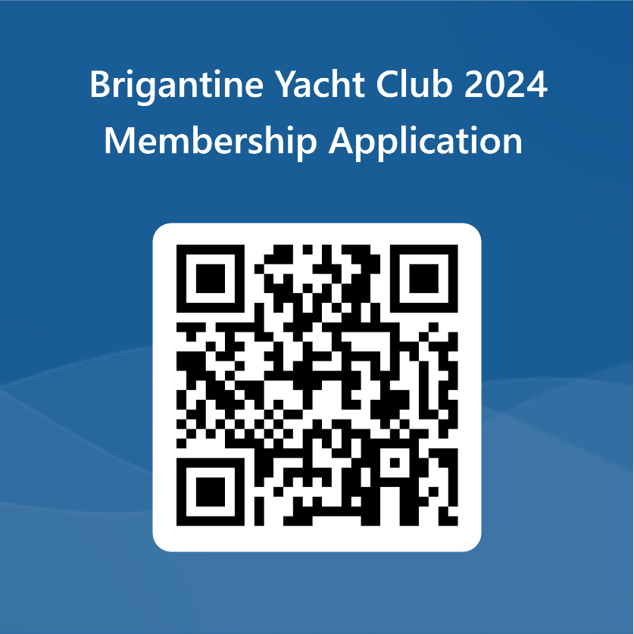

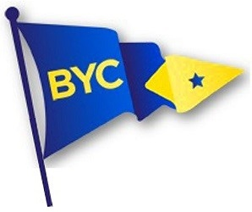

Sarahc352@comcast.net

BYC Application process in five simple steps!

- Learn about the BYC:
  - Explore our website at http://www.bycsail.com/ for club history, photos, bylaws and rules.
  - Talk with any of your friends who are members of the club or contact the membership committee for information: Sarah Chaikin, chairperson (866) BYC-1945, BrigantineYC@gmail.com
  - Take a tour of the clubhouse and grounds.

- Complete and submit a Membership Application:
  - Find sponsors for your application:
    - Two current members in good standing who will submit brief letters of reference OR
    - Sponsorship by the Membership Committee. (In-person or virtual interview required).

- Approve your dues and fees estimate.

- Your application will be reviewed by the Membership Committee and receive a vote by the Trustees. All decisions are final.

- Upon approval:
  - You may use club facilities and participate in social events upon receipt of your Welcome Letter.
  - The Treasurer will send you an invoice for dues and fees. Payment is required within 14 days. (Dues and fees must be paid in full prior to youth participation in our sailing program).
  - The Corresponding Secretary will enter you in the official BYC Directory and include our name in the next BYC Newsletter.
  - You will be introduced as new members at the next General Membership meeting. Please make every effort to attend.

(email preferred) or,
352 11th St. S.
Brigantine, NJ 08203
https://forms.office.com/r/a7U9x3Pjzz

